|  |
| --- |
| PT. BERLIAN SISTEM INFORMASI |
| Operating Lease – Agreement Management Process |
| USER MANUAL GUIDE |
|  |
| **VERSION 2.0** |
| **5/4/2016** |

|  |
| --- |
| All material contained in this manual including text, graphics, icons and images contain proprietary and confidential information of PT. Berlian Sistem Informasi and are protected by international intellectual property and other laws. The compilation of all text, graphics, icons and images in this Manual is the exclusive property of PT. Berlian Sistem Informasi. No modification, rental, lease, sale, transmission, distribution, reposting or creation or derivate works based on the material in this Manual is allowed, unless with the express permission of PT. Berlian Sistem Informasi. |

# REVISION HISTORY

|  |  |  |  |
| --- | --- | --- | --- |
| Date | Revision | Description | Author |
| 1/21/2016 | 0.0 | Initial Document | Sabilla Pravita Larassati |
| 3/3/2016 | 0.1 | Update Document and screenshot | AR. Anggun Cahyaningtyas |
| 3/16/2016 | 0.2 | Compiled with Agreement Approval | AR. Anggun Cahyaningtyas |
| 1.0 | 1st Baseline | AR. Anggun Cahyaningtyas |
| 5/4/2016 | 2.0 | 2nd Baseline | AR. Anggun Cahyaningtyas |

# TABLE OF CONTENT

REVISION HISTORY 2

TABLE OF CONTENT 3

MARKETING MODULE 4

1. MANAGE AGREEMENT 4

PREREQUISITES 4

1.1. Show List of Agreement Record 4

1.2. Filter and Sort Agreement List 7

1.3. Create Agreement (New/Reschedule/Novation) 7

1.4. Edit a Draft Document of Agreement 12

1.5. View an Agreement 15

1.6. Agreement Termination 17

1.7. Agreement Sign by Customer 17

1.8. Print Agreement Form 19

1.9. Print Agreement Report 20

2. AGREEMENT APPROVAL 21

Prerequisites 22

2.1. Check or Revise Agreement 22

2.2. Approve Agreement 25

# MARKETING MODULE

Operating Lease Support System includes Marketing Module features; Calculation of Operating Lease, Quotation of Operating Lease, **Visit Customer Survey, Board of Director Decree / SKD Process, and Agreement Information Inquiry**. All features will be described in the subsequent sections. The Marketing menu of Operating Lease Support System serves as the basic access to marketing module and records of all data. With the marketing menu, you will be able to utilize features of marketing module, including information that will be adjusted through other features of Operating Lease Support System.

Additionally you can enter a record, make changes, and inspect a detail record, and also filter specific records based on columns by writing a keyword on the search field. The features and data contained in your Operating Lease Support System menu are limited by your security and data authorization settings so you may not be able to access all features.

# MANAGE AGREEMENT

Operating lease agreement process occurs after Board of Directors Decree / Surat Keputusan Direksi (SKD) process done. Agreement created based on SKD that has been approved by authorized person from DSF management. Approval from authorized person is highly required in this process, including revision and submission. If agreement is agreed by DSF, it can be signed by Customer. At this business area also explains the process of termination, reschedule, and novation that could be happen at an agreement.

Manage agreement module provides several functions:

1. Create new/reschedule/novation agreement, within save as draft and/or submit.
2. View details of agreement information.
3. Filter and sort function.
4. Modify agreement information; keep them up-to-date.
5. Terminate in progress agreement.
6. Print agreement form.

# PREREQUISITES

User has to login as PIC Admin to start agreement process.

## Show List of Agreement Record

To check the list of Agreement, here is the procedure:

1. Navigate to Marketing module and click “Agreement Information Inquiry”.

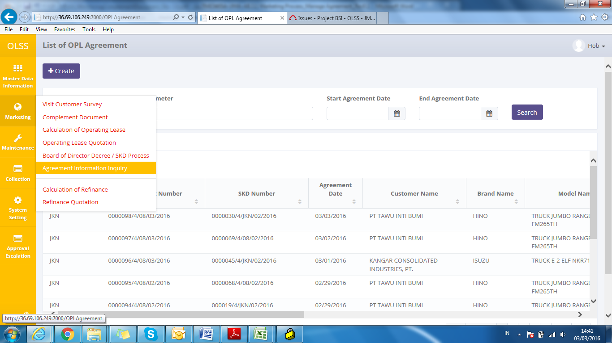

Screen : Agreement Information Inquiry Menu

1. System will show List of Agreement screen that consist of agreement that already recorded in the system. The main page of List of agreement is shown below:

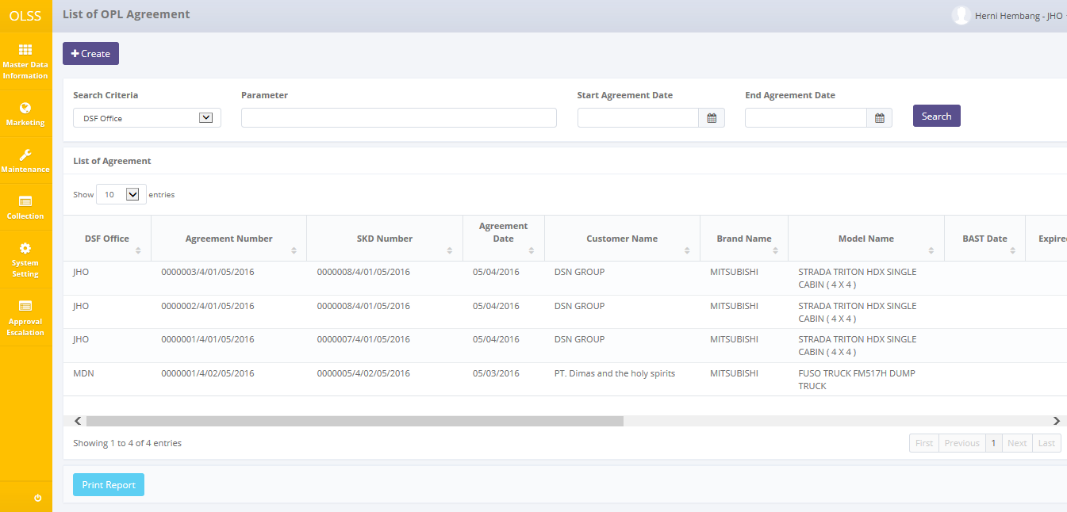

Screen : List of Agreement Information Inquiry

User can see information such as:

DSF Office, Agreement Number, SKD number, Agreement Date, Customer Name, Brand Name, Model Name, BAST Date, Expired Date, Terminate Date, Created By, Created Date, Last Approve By, Next Approve By, Status, and Action row.

Agreement statuses are divided into 15 types:

1. 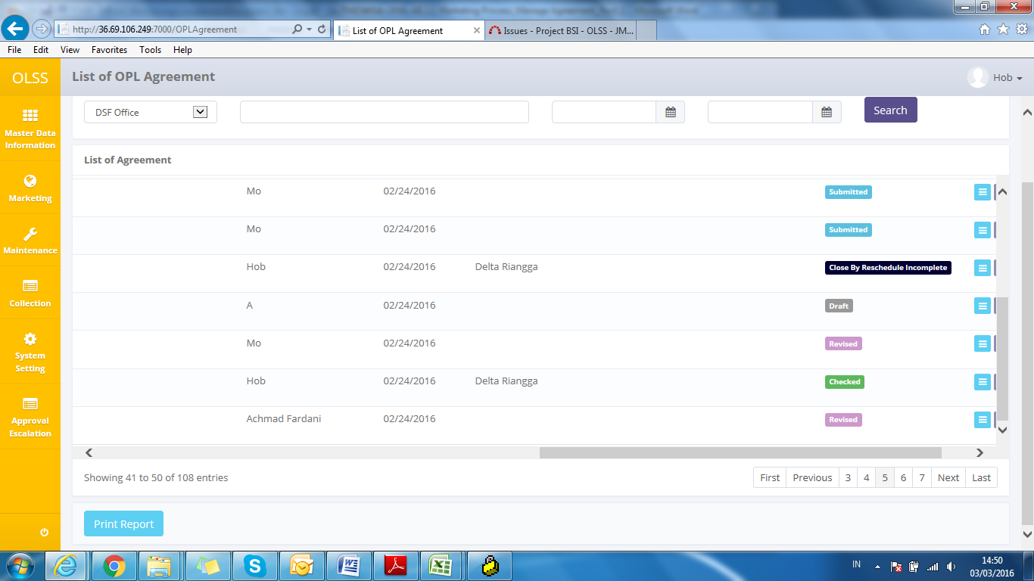, agreement hasn’t been submitted by admin, still can be edited.
2. , agreement can no longer be edited, and ready to be checked by DSF management.
3. 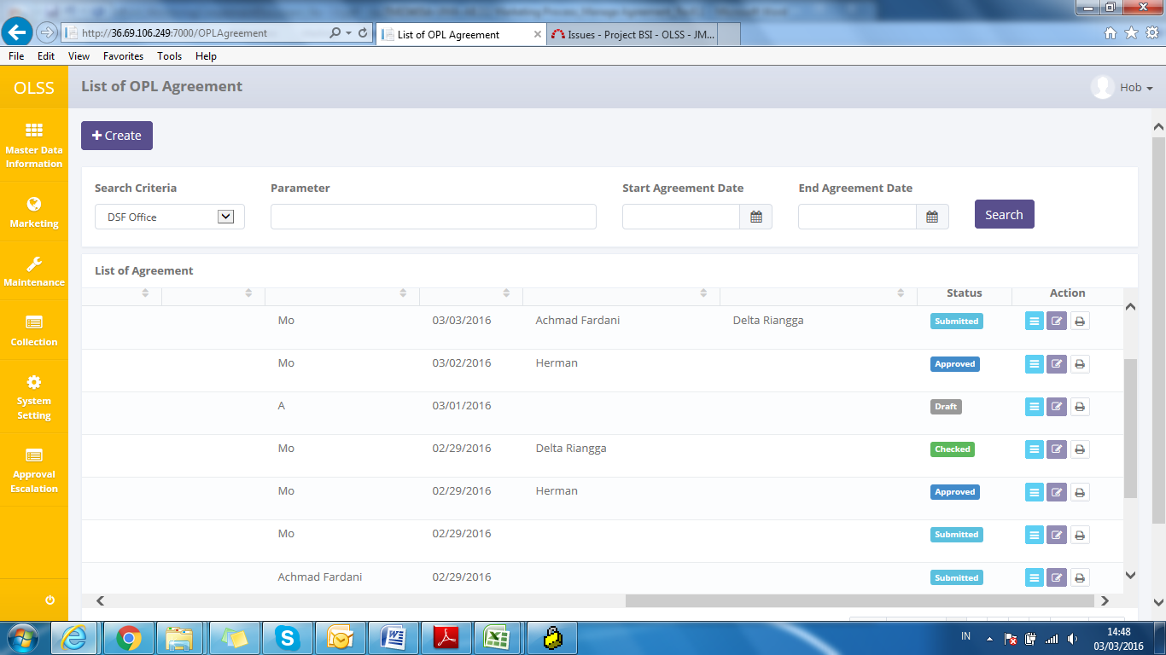, the document has been checked by DSF management, and continue to next approval hierarchy.
4. , the document has some mistakes and the authorized user has revised it and need to be submitted back by PIC Admin.
5. 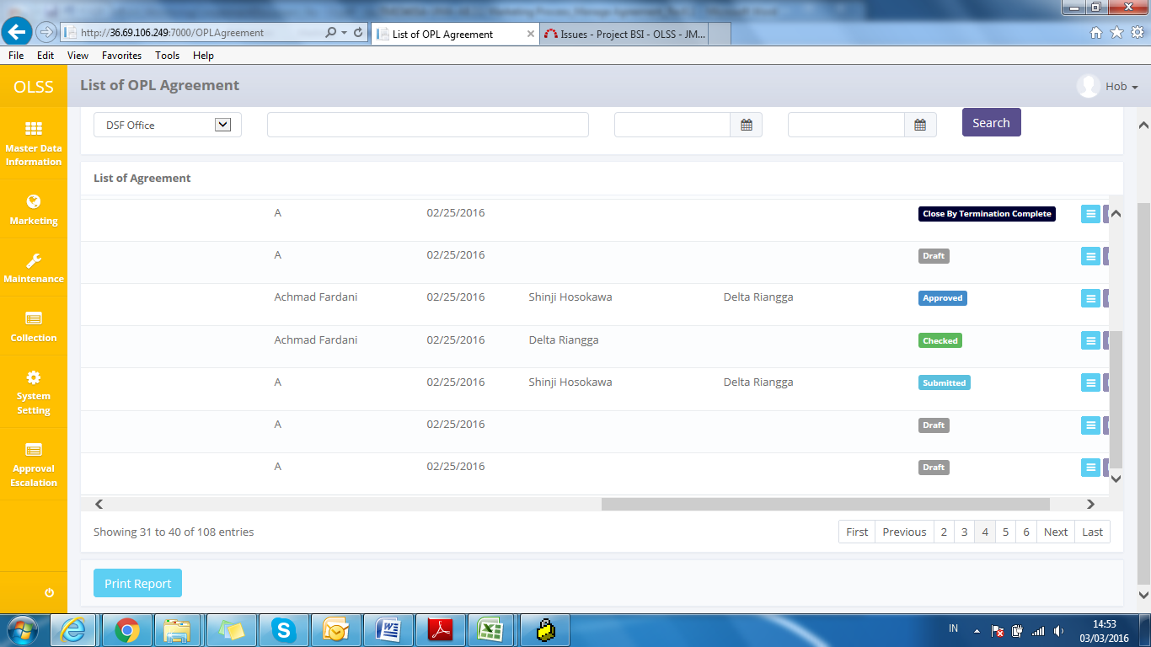, the document has been approved by the highest hierarchy approver.
6. 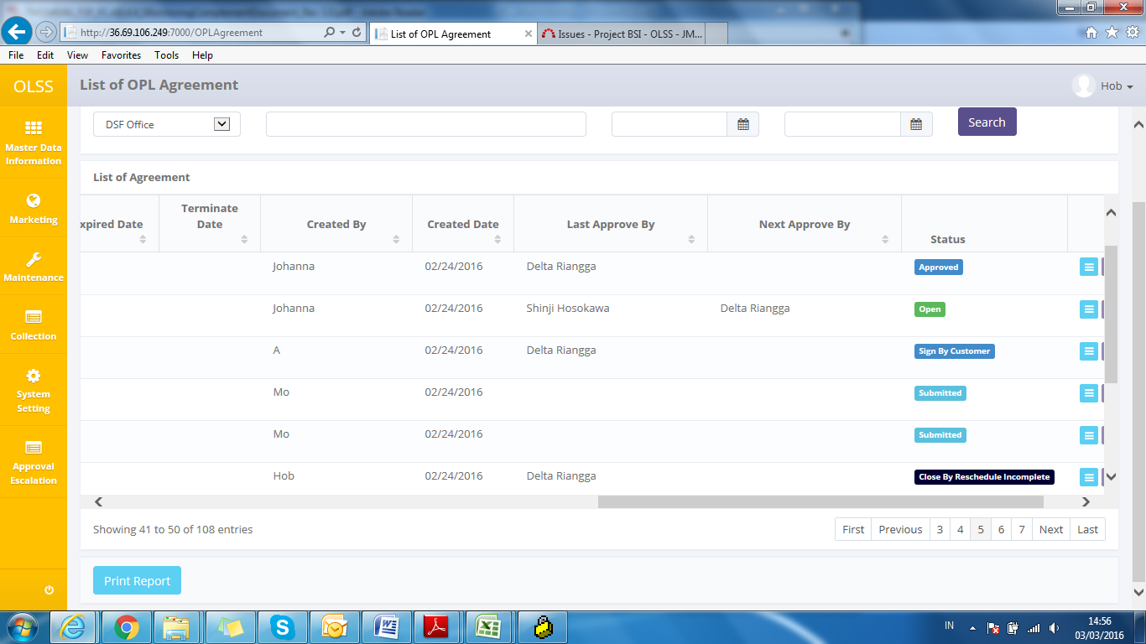, the document has been approved by customer.
7. , agreement status will automatically change after BAST process has finished.
8. , agreement status will automatically change when agreement period is over and still had overdue billing.
9. , agreement status will automatically change when agreement period is over and had no overdue billing.
10. 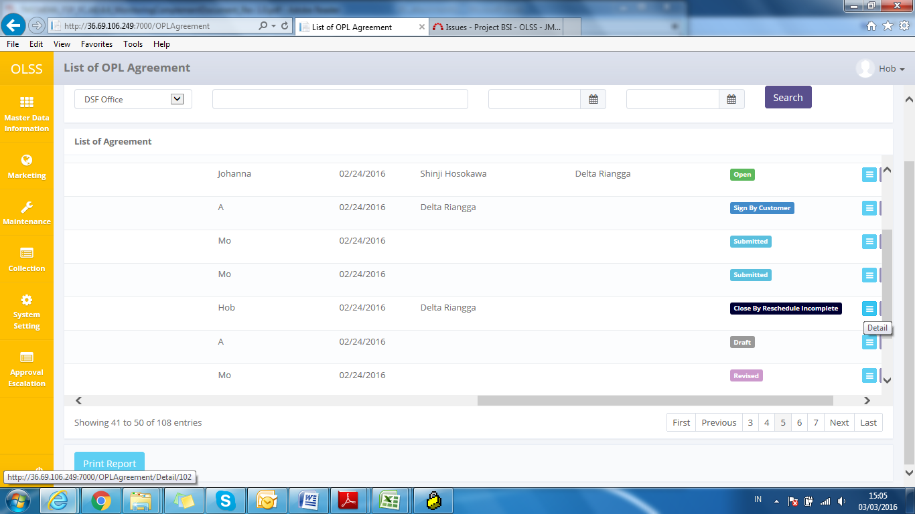, agreement status will automatically change when Agreement with type “Reschedule” already sign by customer and previous agreement that set as a reference still has overdue billing.
11. C:\Users\BSI00829\Documents\Untitled.png, agreement status will automatically change when Agreement with type “Reschedule” already sign by customer and previous agreement that set as a reference had no overdue billing.
12. 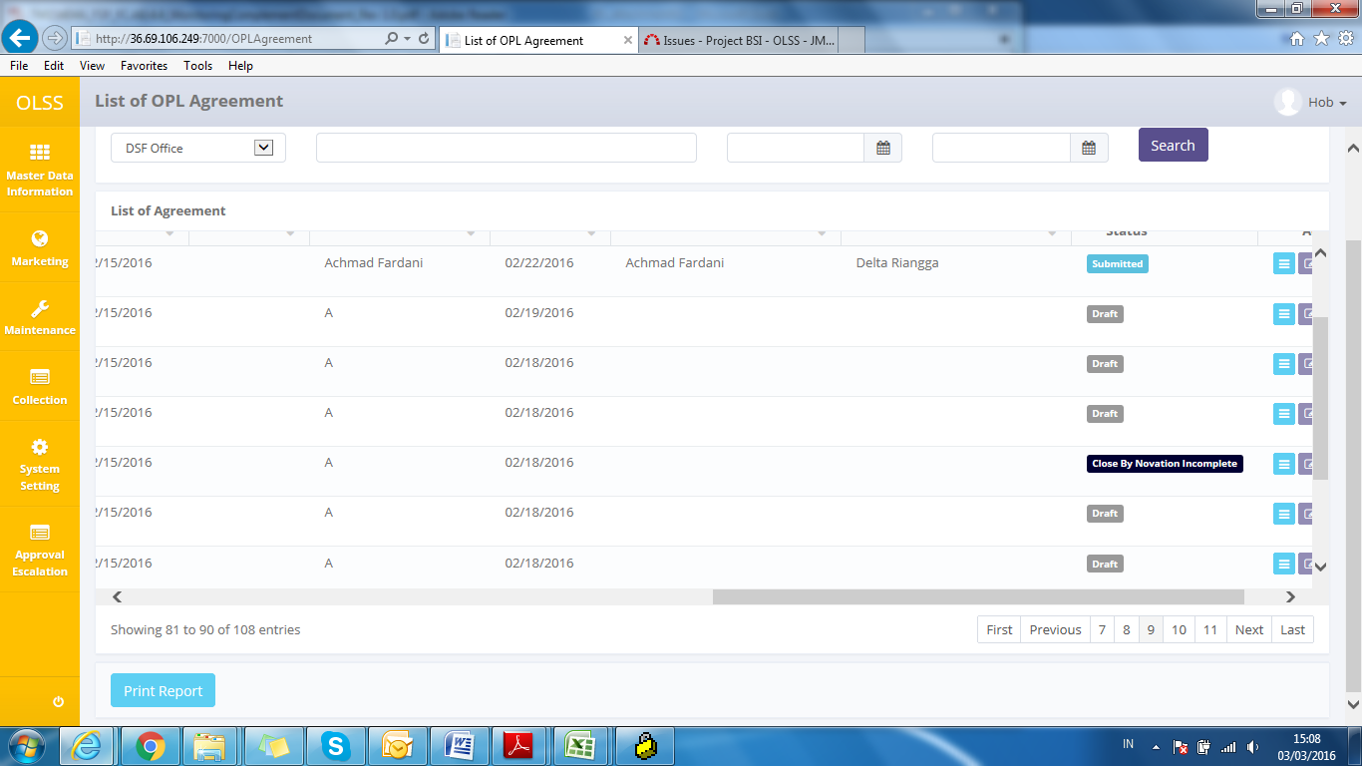, agreement status will automatically change when Agreement with type “Novation” already sign by customer and previous agreement that set as a reference and still has overdue billing.
13. C:\Users\BSI00829\Documents\Untitled.png, agreement status will automatically change when Agreement with type “Novation” already sign by customer and previous agreement that set as a reference had no overdue billing.
14. , agreement status will automatically change when Agreement with type “Termination” already sign by customer and previous agreement that set as a reference still has overdue billing.
15. 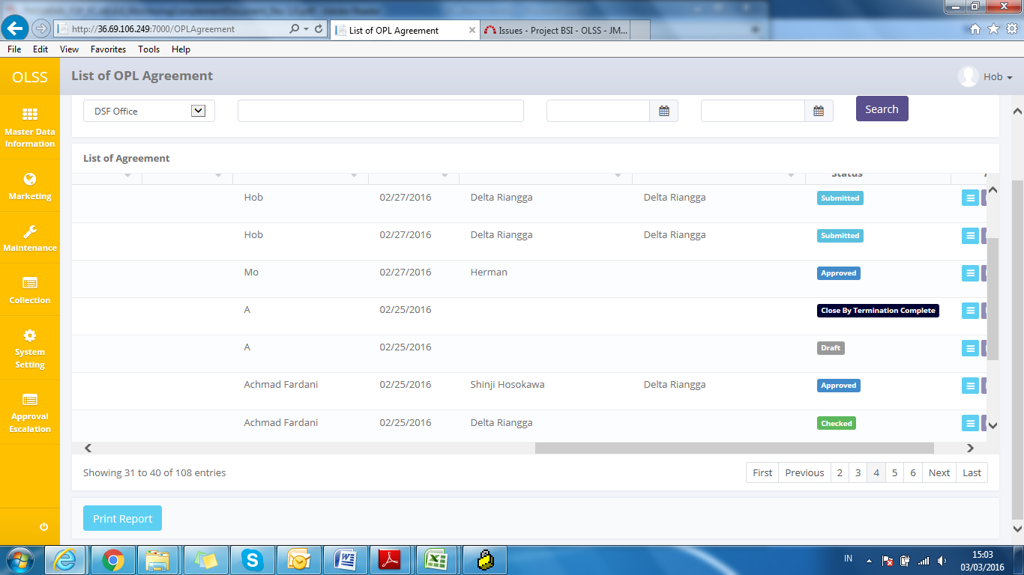, agreement status will automatically change when Agreement with type “Termination” already sign by customer and previous agreement that set as a reference had no overdue billing.

On the List of Agreement screen, there will be five buttons, which are:

* 1. : On top-left screen, click the button to create new agreement.
  2. : In the action column in each record, click the button to view agreement details.
  3. : In the action column in each record, click the button to modify agreement information.
  4. : In the action column in each record, click the button to print agreement form.
  5. : On bottom-left screen, click the button to print report agreement list.

## Filter and Sort Agreement List

To filter the records there are three categories as follows:

1. To sort the record alphabetically by column, user can click  on the column title on the table header.
2. User can select the number of records that want to be showed by picking this feature  on the screen. If the records have been filtered based on number, the amount of records that will be shown is the same as the selected number.
3. User can filter the records with the specific information by entering the keywords on the search field shown below:

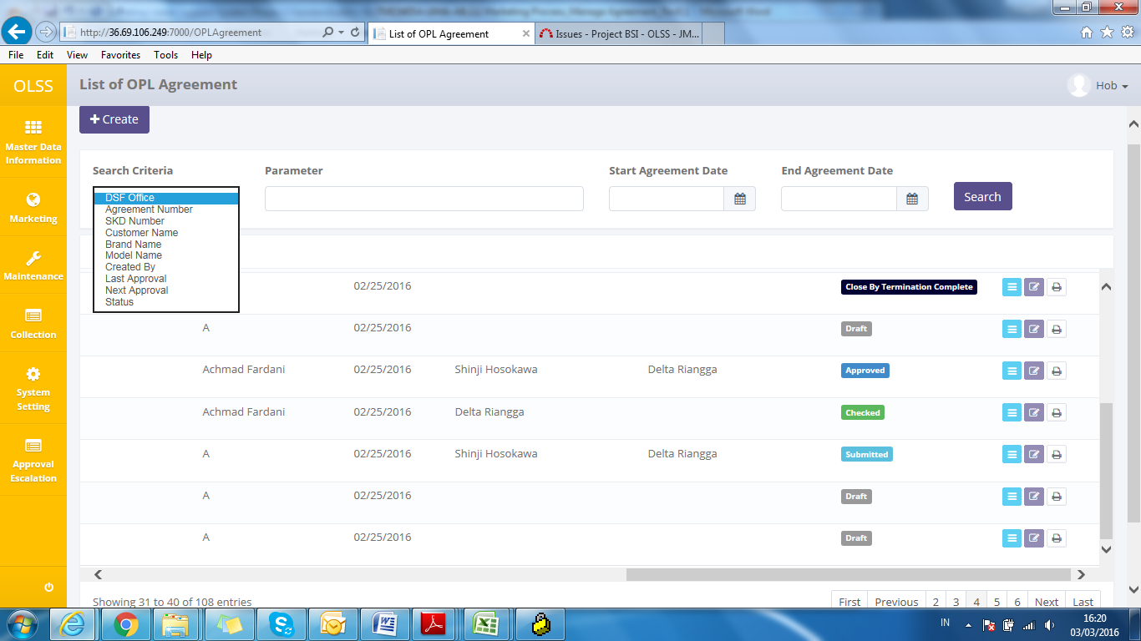

Screen : Search Criteria

Search criteria consist of data master:

Parameter can be filled with keywords that user want to search. To get more specific results, user can also insert the agreement date (Start Agreement Date and End Agreement Date). For example, you can find name by filling the keywords in parameter, and pick **Customer Name** in Search Criteria, then pick the exact date, and press Search button to get the results.

## Create Agreement (New/Reschedule/Novation)

To create agreement, find and click Create on top of the List of agreement Screen.

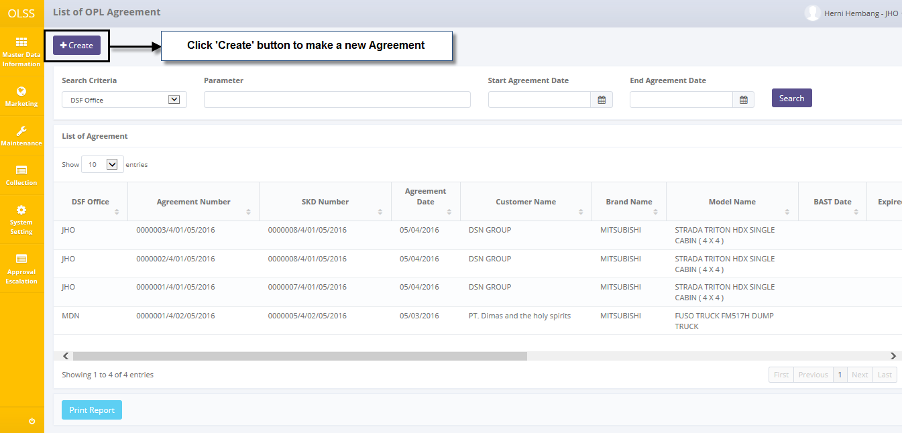

Screen : Navigate to Create Agreement

System will show Create Agreement Screen shown below:

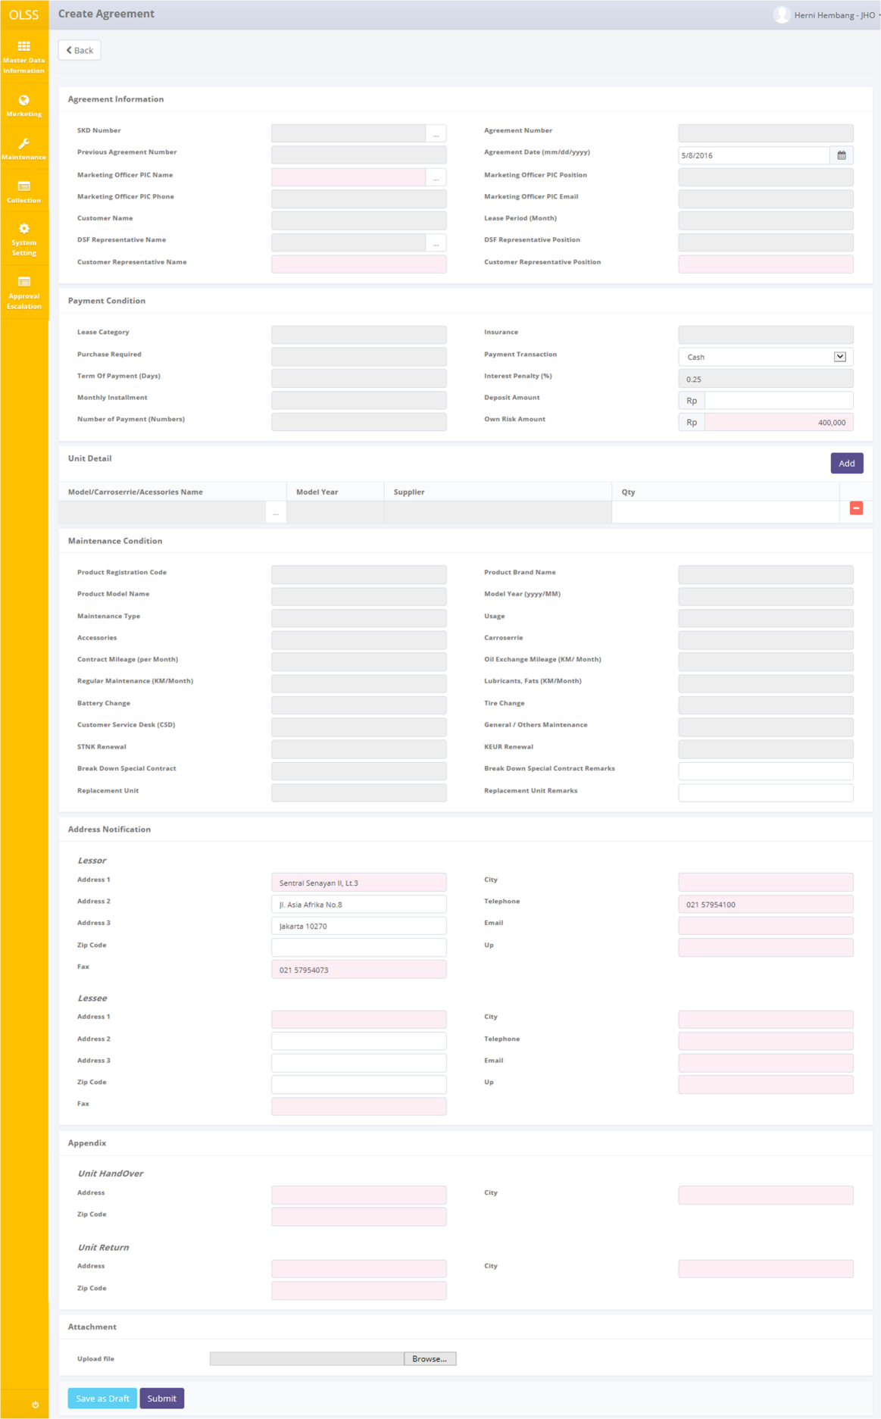

Screen : Screen of Create Agreement

Once the Create agreement screens open, user has to fill information on the blank field. The fields are:

1. Agreement Information:
   1. SKD Number: Select SKD number. If selected SKD is created using rescheduled or novation agreement, previous Agreement Number will show up in Previous Agreement Number field. Selecting SKD number will trigger new Agreement Number and automatically load up SKD information.
   2. Marketing Officer PIC Name: change PIC Admin name (if needed).
   3. DSF Representative Name: select DSF representative name. After select DSF Representative Name, DSF Representative Position field automatically filled.
   4. Customer Representative Name: input representative name.
   5. Agreement Date: input current date. Agreement date can’t be less than SKD date.
   6. Customer Representative Position: input customer representative position.
2. Payment Condition:
   1. Payment Transaction: Pick “Transfer” or “Giro”.
   2. Deposit Amount: fill information about deposit. Input with numbers.
   3. Insurance Claim Amount : input amount of insurance claim.
3. Unit Detail:

Click “Add” button, to add unit list. Unit information already inputted before in SKD creation, but one SKD document could be made into two or more agreement for the case where one model is supplied by different supplier and in different time. So in agreement document, user has to input the quantity and model again.

1. Maintenance Condition:
   1. Break Dawn Special Contract Remarks: fill information about the special contract with reasonable remarks.
   2. Replacement Unit Remarks: fill information with reasonable remarks.
2. Address Notification :
   1. Lessor
      1. Address 1: edit DSF branch/head office address 1 (if needed).
      2. Address 2: edit DSF branch/head office address 2 (if needed).
      3. Address 3: edit DSF branch/head office address 3 (if needed).
      4. Zipcode: fill zipcode of DSF branch/head office.
      5. Fax: fill fax number of DSF branch/head office.
      6. City: fill city of DSF branch/head office.
      7. Telephone: fill telephone number of DSF branch/head office.
      8. Email: fill information about email PIC DSF as a lessor who can called about the agreement.
      9. Up: fill information about name of PIC DSF as a lessor who can called about the agreement.
   2. Lessee
      1. Address 1: fill information about lessee office address 1.
      2. Address 2: fill information about lessee office address 2.
      3. Address 3: fill information about lessee office address 3.
      4. City: fill information about city of lessee office.
      5. Zipcode: fill information about zipcode of lessee office.
      6. Telephone: fill information about telephone of lessee office.
      7. Fax: fill information about fax of lessee office.
      8. Email: fill information about email of PIC lessee.
      9. Up: fill information about name of PIC lessee, it is can more than one person.
3. Appendix :
   1. Unit Handover
      1. Address: fill information about address to handover the unit.
      2. City: fill information about city to handover the unit.
      3. Zipcode: fill information about zipcode to handover the unit.
   2. Unit Return
      1. Address: fill information about address to return the unit.
      2. City: fill information about city to return the unit.
      3. Zipcode: fill information about zipcode to return the unit.

There are three buttons that will be displayed on the screen as follows:

1. , on the top-left corner of the screen.
2. , on the bottom-left corner of the screen.
3. , on the bottom-left corner of the screen.

After the data entered on the screen, user can save the information on the system by clicking **Save as Draft** button, or **Submit** button. Ensure that you actually want to **Submit** a record, because the records can’t be reserved and update after submitted by user.

There are mandatory fields marked with red background field that should be inputted including: SKD Number, Marketing Officer PIC Name, DSF Representative Name, Customer Representative Name, DSF Representative Posistion, Customer Representative Position, Insurance Claim Amount, Model/Carroserrie/Accessories Name, Lessor Email, Lessor Up, Lessee Address, Lessee City, Lessee Zipcode, Lessee Telephone, Lessee Fax, Lessee Email, Lessee Up, Unit Handover Address, Unit Handover City, Unit Handover Zipcode, Unit Return Address, Unit Return City, and Unit Return Zipcode. It can’t leave as blanks. If you leave them blanks, system will notified it after you clicking **Save as Draft** or **Submit** button.

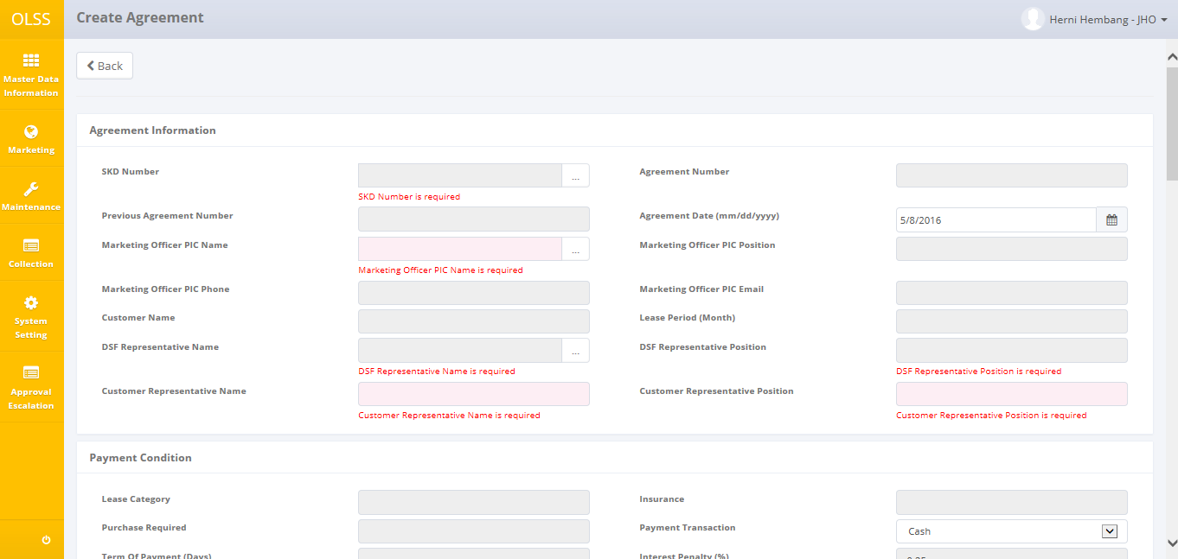

Screen : Error notification after Save as Draft/Submit

After clicking **Save as Draft** or **Submit** button, system will notified if it success or failed to save or submit a data.



Screen : Success notification after Save as Draft



Screen : Success notification after Submit

## Edit a Draft Document of Agreement

To edit agreement record, navigate to the List of OPL Agreement and click Edit button on the right side of the record with status  or. To edit agreement must be user who create the agreement.

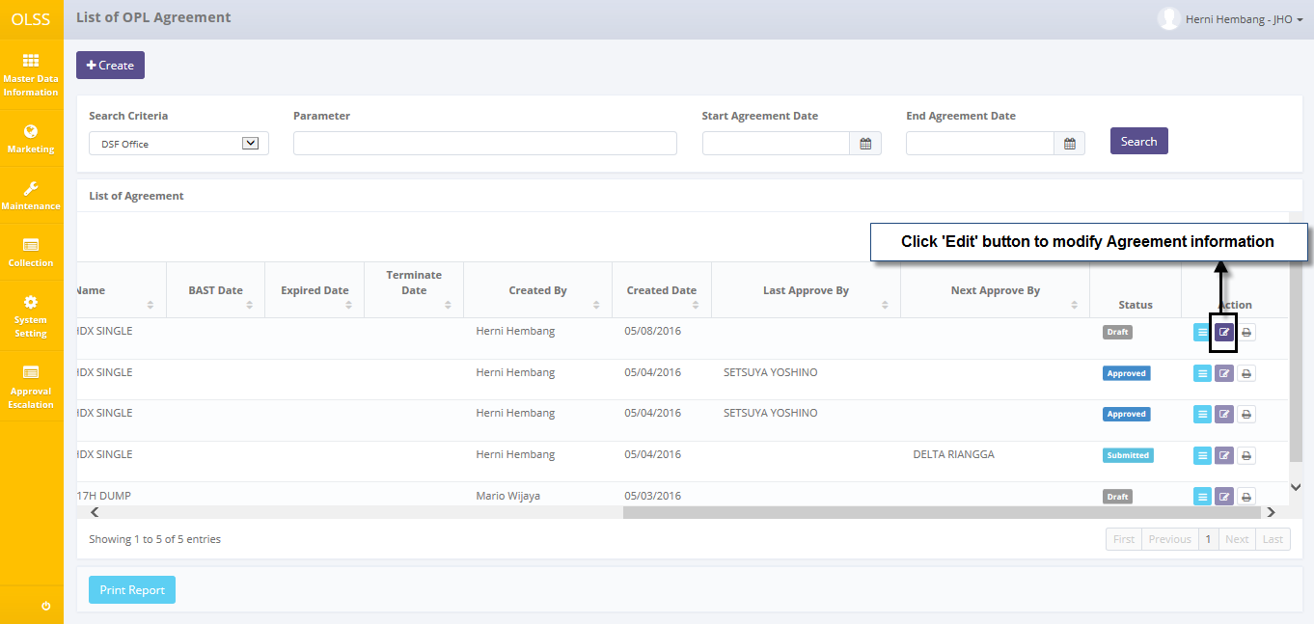

Screen : Navigate to Edit Agreement

The screen below is shown after the Edit button is clicked.

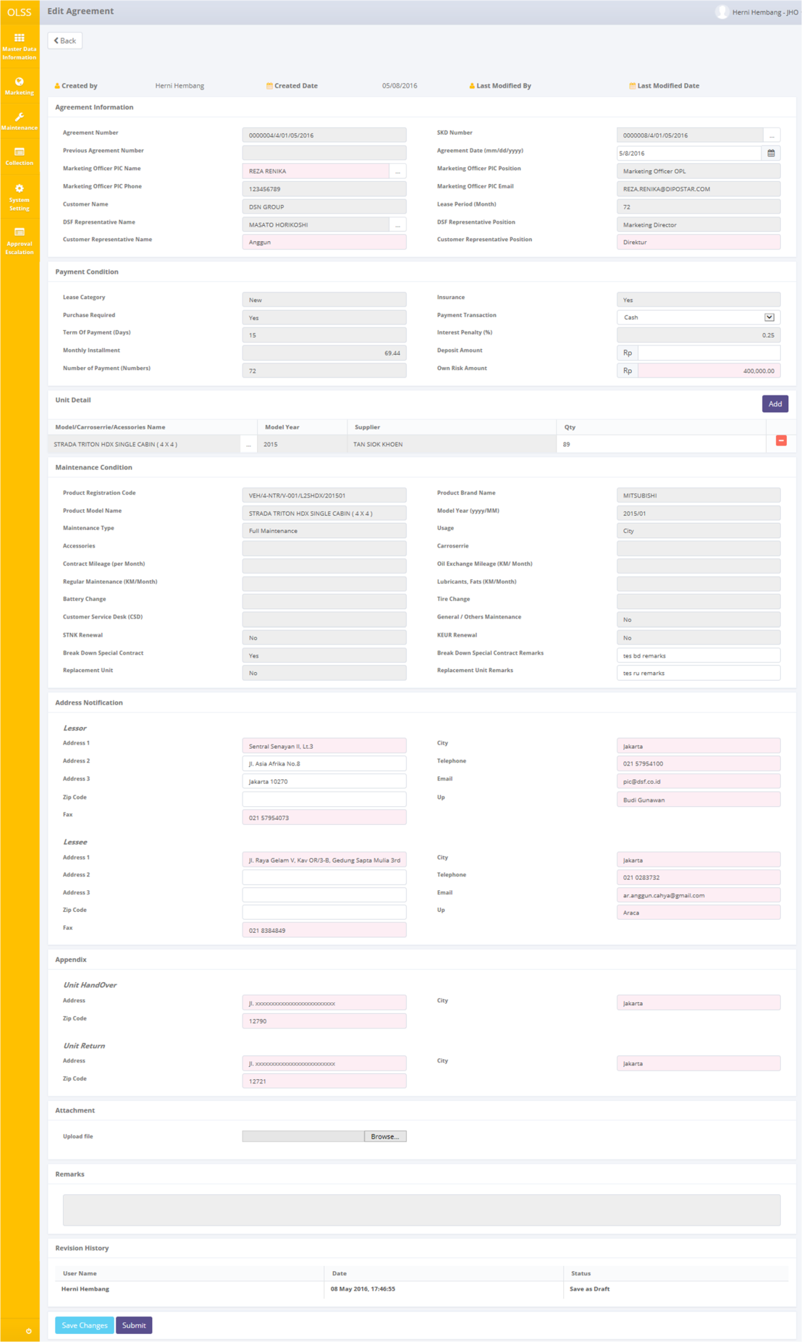

Screen : Screen of Edit Agreeement

Once the Edit Agreement screens open, user can edit existed information. There are three buttons that will be displayed on the screen as follows:

1. , on the top-left corner of the screen.
2. , on the bottom-left corner of the screen, clicking this will made agreement status changed into .
3. , on the bottom-left corner of the screen, clicking this will made agreement status changed into .

There is a Revision History field on the bottom of the screen, consist of the user information that had make changes to the records. If data already changed on the screen, user can save a data on the system by clicking **Save Changes** button, or **Submit** button. Ensure that you actually want to **Submit** a record, because the records can’t be reserved and update after submitted by user.

There are mandatory fields marked with red background field that should be inputted including: SKD Number, Marketing Officer PIC Name, DSF Representative Name, Customer Representative Name, DSF Representative Posistion, Customer Representative Position, Insurance Claim Amount, Model/Carroserrie/Accessories Name, Lessor Email, Lessor Up, Lessee Address, Lessee City, Lessee Zipcode, Lessee Telephone, Lessee Fax, Lessee Email, Lessee Up, Unit Handover Address, Unit Handover City, Unit Handover Zipcode, Unit Return Address, Unit Return City, and Unit Return Zipcode. It can’t leave as blanks. If you leave them blanks, system will notified it after you clicking **Save Changes** or **Submit** button.

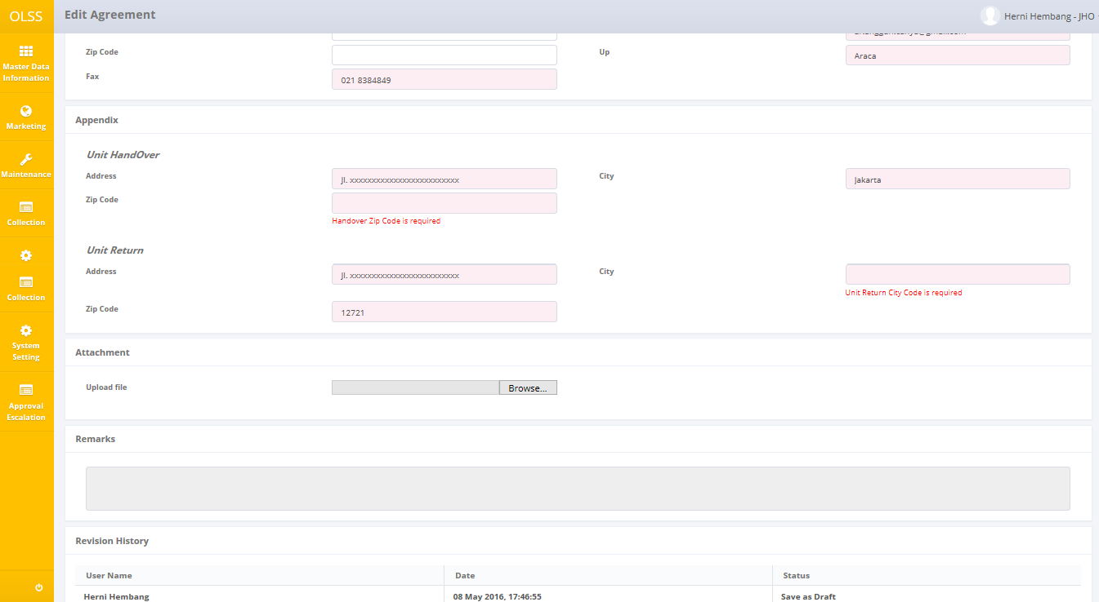

Screen : Error notification after Save Changes/Submit

After clicking **Save Changes** or **Submit** button, system will notified if it success or failed to save or submit a data. You also have a **Back** button, which redirect you to the previous page, List of Agreement page.



Screen : Success notification after Save Changes



Screen : Success notification after Save Changes

## View an Agreement

To view the records, you can select a record from the List of Agreement page by clicking the action button , on the rightmost column.

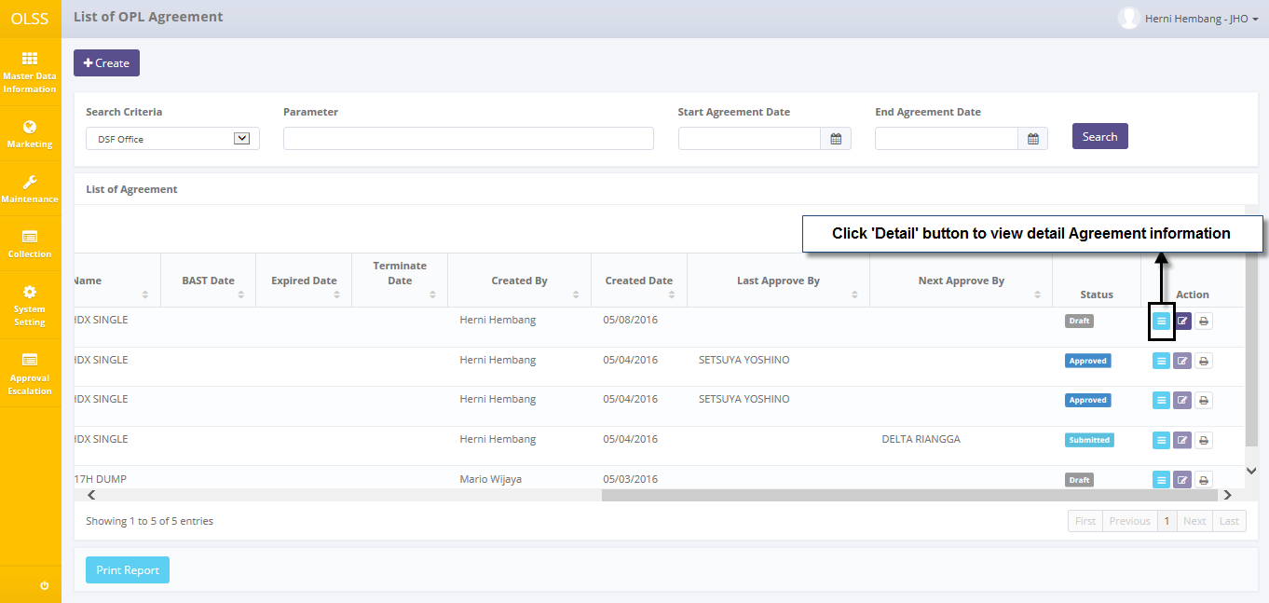

Screen : Navigate to View Detail Agreement

Screen will show View Agreement screen shown below:

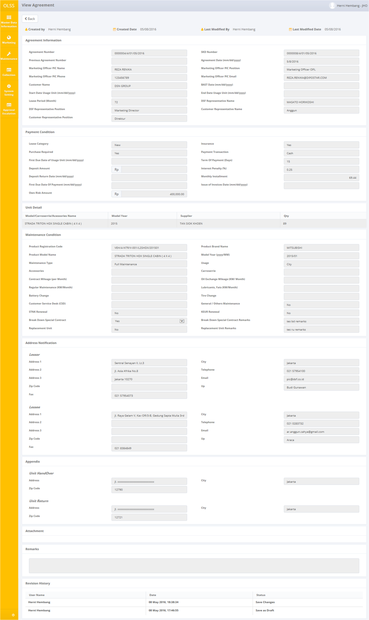

Screen : Screen View Detail Agreement

User can check the records but the records cannot be clicked or edited. Here you can see the detail information related with Agreement Data, such as; Agreement Information, Payment Condition, UnitDetail/List of Unit (Object Lease), Maintenance Condition, Address Notification, Appendix, Attachment, Remarks, and Revision History. There are a buttons that will be displayed on the screen as follows:

1. , to go to previous screen: List of OPL Agreement.

## Agreement Termination

Agreement could be discontinued after it has been processed. To terminate agreement, PIC Admin can navigate to List of Agreement and click “View” on agreement that want to be terminated. Agreement that can be terminated is only agreement with status “Open”.

Terminate button only available if the agreement is “Open”. Click “Terminate” button on the bottom of the screen.

After the agreement has been terminated, agreement status will changed into **Close by Termination**. If the agreement still has overdue billing, then the status will be **Close by** **Termination Incomplete**. If the agreement have no overdue billing, then the status will be **Close by Termination Complete**.

## Agreement Sign by Customer

Approved agreement will show up in List of Agreement as  agreement. Before approved agreement can be processed for Purchase Order, agreement document should be Sign by Customer. Admin will print the approved agreement, then getting the document signed by related customer.

After that, admin can update agreement status on system, by navigating to List of Agreement and clicking “View” button on related document.

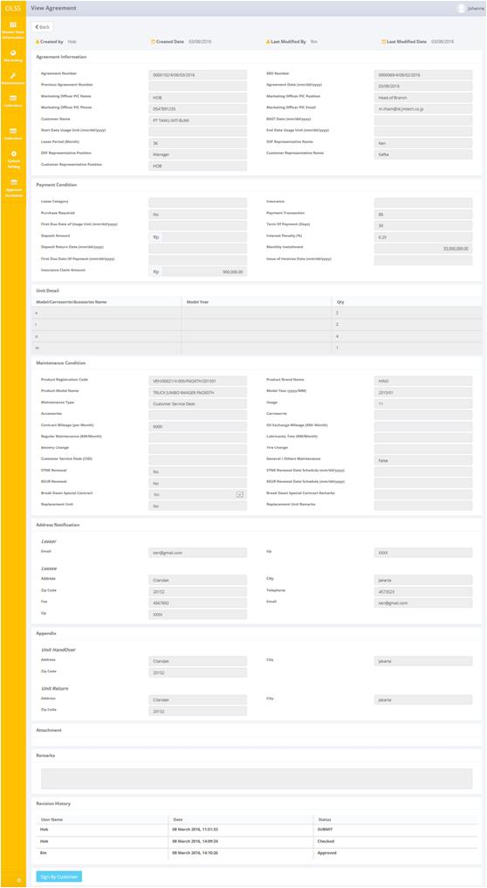

Screen 16: Screen Sign by Customer

Click “Sign by Customer” on the bottom of the screen.

Document status now is “Signed by Customer” and notification will show up at the top of the screen.

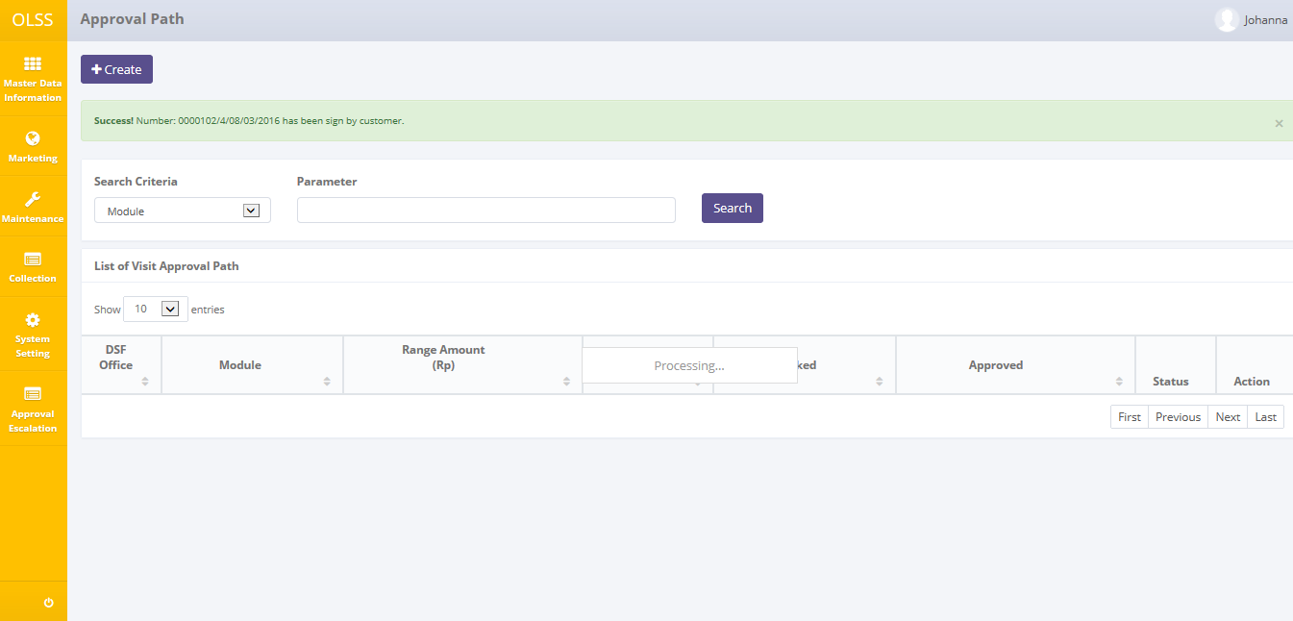

Screen 17: Success Notification of Sign by Customer

After done viewing the records, you can click **Back** button, to redirect you to the previous page, List of Agreement Page.

## Print Agreement Form

User can also print the Agreement by clicking the button  on the List of Agreement screen as shown below:

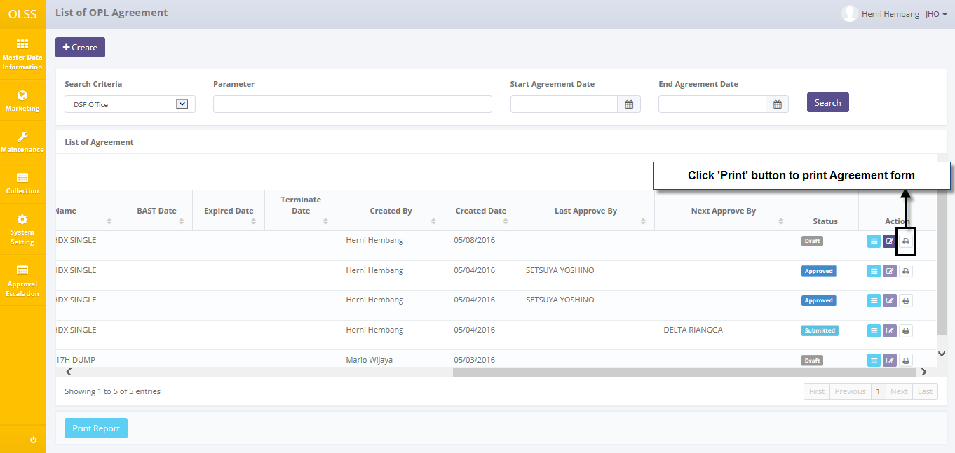

Screen : Navigate to Print Form Agreement

After clicking the button, there will be a pop up to give user confirmation whether the user wants to convert the file or not. The convert options are PDF and Excel**.**

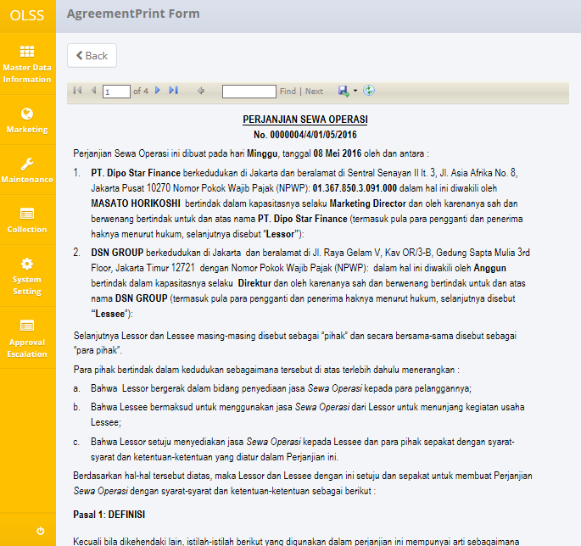

Screen : Preview Agreement Form

## Print Agreement Report

Aside from printing Agreement report, user can print the entire agreement list that has been recorded in the database. To print the report, user can click button on the bottom of List of Agreement Screen.

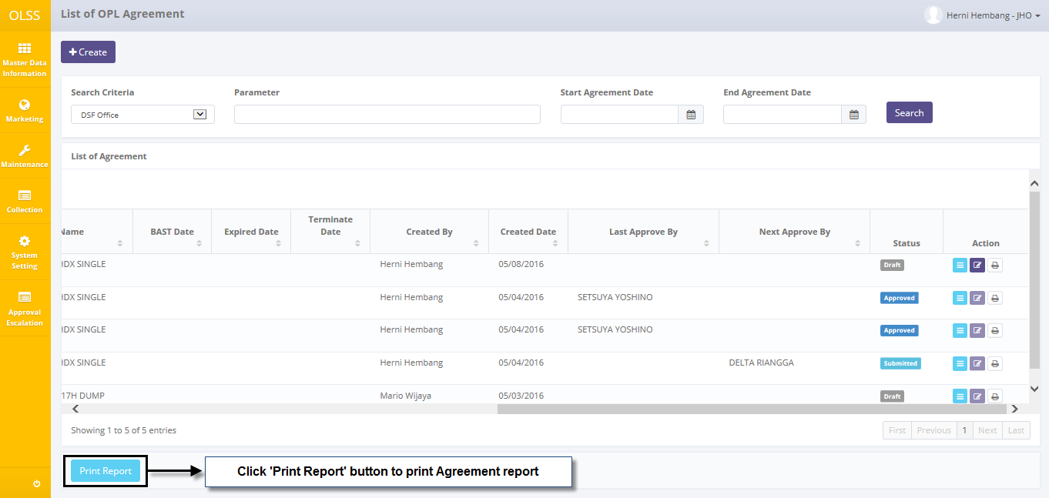

Screen : Navigate to Print Report Agreement List

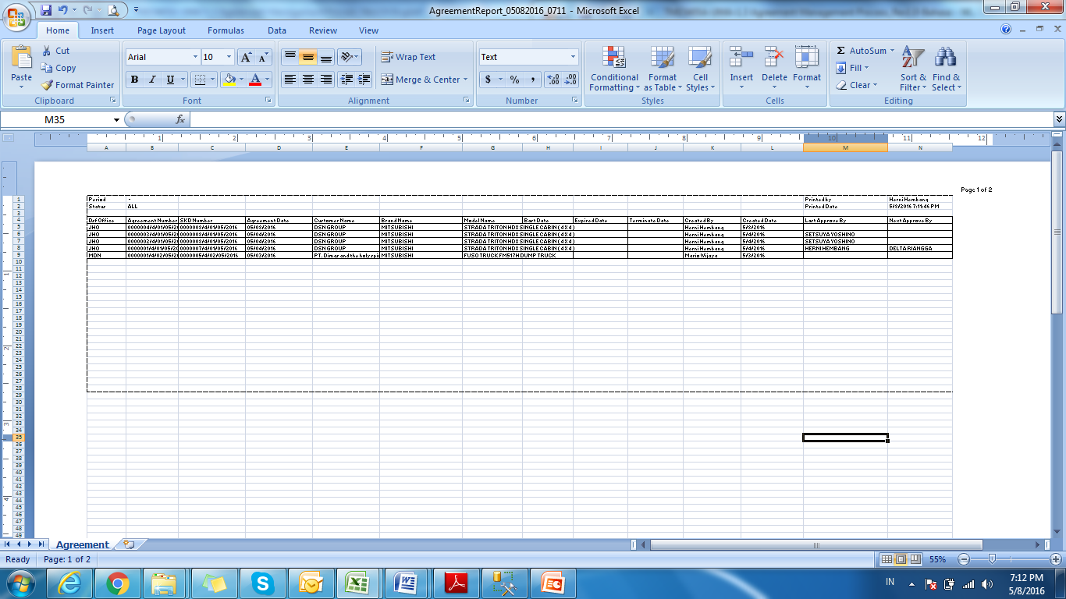

Screen : Report Agreement List

# AGREEMENT APPROVAL

Agreement can be approved once it is submitted by DSF Marketing Officer. Agreement will be approved by DSF management which is: Head of Branch/Head of Division, Regional Manager/Advisor, and Director. Approval hierarchy is based on SKD Net Investment Nominal. The highest the nominal, the higher the hierarchy to check and approve Agreement. The nominal table can be seen below:

Table 1: Nominal Table

|  |  |  |  |
| --- | --- | --- | --- |
| **Amount Range (IDR)** | **Proposed** | **Checked** | **Approve** |
| 0 – 100.000.000 | MO | HOB | RM |
| 100.000.001 – 500.000.000 | MO | HOB, RM | Advisor |
| 500.000.001 - 1.000.000.000 | MO | HOB, RM, Advisor | Director |
| 1000.000.001 – 2.000.000.000 | MO | HOB, RM, Advisor, Director | President Director |

Agreement approval is slightly different than SKD approval. Agreement only needs to be checked by one authorized person, before approved by the highest hierarchy user. Agreement approval flow (based on nominal table) can be described as:

Case 1: Agreement checked by HOB and approved by RM.

Case 2: Agreement checked by HOB, if HOB not available in certain time, it will move to the next authorized person: Regional Manager then approved by advisor.

Case 3: agreement checked by HOB, if HOB not available in certain time, it will move on to the next authorized person: Regional Manager, if RM still not available in certain time, it will move on to the next authorized person: Advisor then approved by Director.

Agreement approval module provides several functions:

1. Check or Revise agreement information.
2. Approve agreement.

# Prerequisites

Before user can approve agreement, user has to login using their own credential username, example: as HOB, RM, and director.

## Check or Revise Agreement

To start checking agreement record, navigate to the List of agreement and click View button on the right side of the record with status .

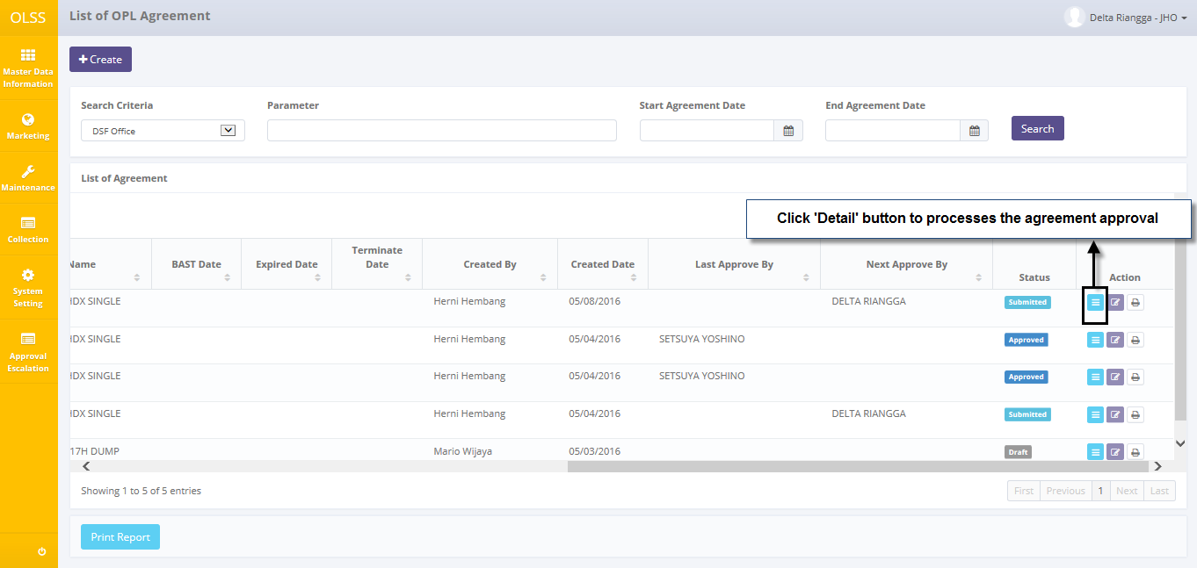

Screen : Details button on List of OPL Agreement

The screen below is shown after the Details button is clicked.

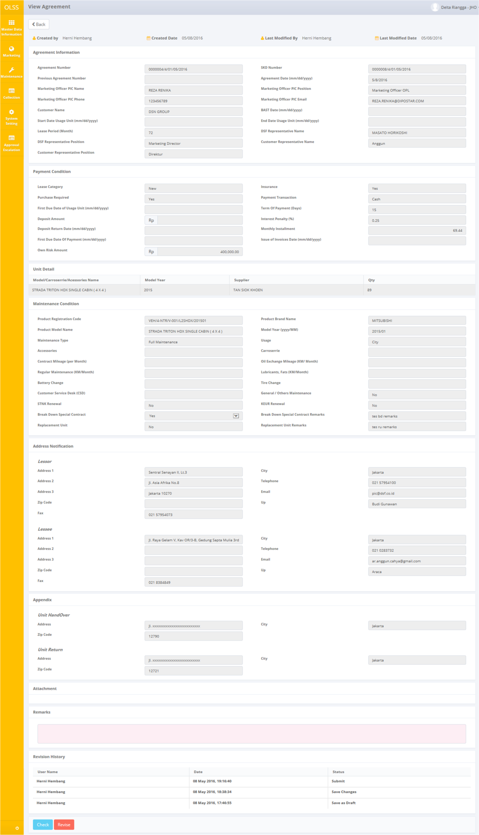

Screen : View Agreement Screen

Once the view agreement screens open, user can check the information existed. There are three buttons that will be displayed on the screen as follows:

1. , to go to previous screen: list of agreement.
2. , to give a sign that current approver has approve the document and ready to send the document to the next approver, will not active for the highest hierarchy approver (refer to nominal table).
3. , to give a sign that the document has been revised and need to be submitted again by Marketing Officer.

Some of these buttons will active only for the authorized person. Authorized user can check which document should be checked by seeing Next Approval Column in List of agreement. For example: HOB can only click “Check” and “Revise” on the document that has HOB name as “Next Approval By”.

While checking, if agreement document still need to be revised, input the remarks and click “Revise” button. The document will sent back to MO to be submitted back. If data has no more mistakes, user can click “Check” to continue the document to be checked by next approver.

After clicking **Check** or **Revised** button, system will notified if it success or failed to save or submit a data.



Screen : Success notification after agreement is checked.



Screen : Success notification after document is revised

Then the document can no longer be edit by current user, because the authority has been passed to the next approver. For this case, if HOB is the current user, HOB can’t edit the document.

## Approve Agreement

Agreement can only be approved by the highest hierarchy (refer to nominal table). To approve Agreement, user has to navigate to the list of agreement and click Details button on the right side of the record with status  and has the highest hierarchy name as next approver. For example: if the highest hierarchy for the case is Director, then the “Next Approver” name should be Director Name.

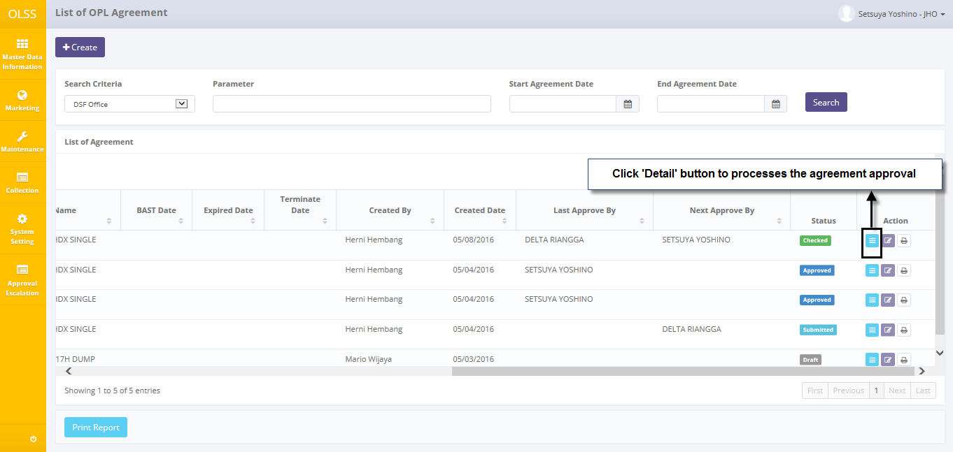

Screen : details button on list of OPL Agreement

View agreement screen will show up, and on the bottom of the screen there are 1 active buttons:

1. , to give a sign that the document has been agreed.

While checking, if agreement still needs to be revised, edit the information and click “Revise” button. The document will sent back to MO to be submitted back. If data has no more mistakes, user can click  button. If the user approves the agreement, the documents will be sent back to MO and will have “Approved” status in List of agreement. Then the document will be ready to be signed by customer.

After clicking **Approve** button, system will notified if it success or failed to save or submit a data.



Screen : Success notification after agreement is approved

Then the document can no longer be edit by current user, because the authority has been passed to Marketing Officer.